Strategies Explained

The only limiting factor for strategies is the thought of the trader/ strategy designer. As long as the trader can think of innovative combinations of various options, newer strategies will keep coming to the market. Exotic products (or ‘exotics’) are nothing but a combination of different derivative products. In this section, we will see some of the most commonly used strategies.
Option Spreads
Spreads involve combining options on the same underlying and of same type (call/ put) but with different strikes and maturities. These are limited profit and limited loss positions. They are primarily categorized into three sections as:
    - Vertical Spreads
    - Horizontal Spreads
    - Diagonal Spreads
Vertical Spreads
Vertical spreads are created by using options having same expiry but different strike prices. Further, these can be created either using calls as combination or puts as combination. These can be further classified as:
    - Bullish Vertical Spread
      - Using Calls
      - Using Puts
    - Bearish Vertical Spread
      - Using Calls
      - Using Puts
Bullish Vertical Spread using Calls
A bull spread is created when the underlying view on the market is positive but the trader would also like to reduce his cost on position. So he takes one long call position with lower strike and sells a call option with higher strike. As lower strike call will cost more than the premium earned by selling a higher strike call, although the cost of position reduces, the position is still a net cash outflow position to begin with. Secondly, as higher strike call is shorted, all gains on long call beyond the strike price of short call would get negated by losses of the short call. To take more profits from his long call, trader can short as high strike call as possible, but this will result in his cost coming down only marginally, as higher strike call will fetch lesser and lesser premium.
Say, for example, a trader is bullish on market, so he decides to go long on 5800 strike call option by paying a premium of 300 and he expects market to go not above 6200, so he shorts a 6200 call option and receives a premium of 145. His pay off for various price moves will be as follows:

Option | Call | Call
Long/Short | Long | Short
Strike | 5800 | 6200
Premium | 300 | 145
Spot | 6000
CMP | Long Call | Short Call | Net Flow
5000 | -300 | 145 | -155
5100 | -300 | 145 | -155
5200 | -300 | 145 | -155
5300 | -300 | 145 | -155
5400 | -300 | 145 | -155
5500 | -300 | 145 | -155
5600 | -300 | 145 | -155
5700 | -300 | 145 | -155
5800 | -300 | 145 | -155
5900 | -200 | 145 | -55
6000 | -100 | 145 | 45
6100 | 0 | 145 | 145
6200 | 100 | 145 | 245
6300 | 200 | 45 | 245
6400 | 300 | -55 | 245
6500 | 400 | -155 | 245
6600 | 500 | -255 | 245
6700 | 600 | -355 | 245
6800 | 700 | -455 | 245
6900 | 800 | -555 | 245
7000 | 900 | -655 | 245

1000
Bull Call Spread Payoff
5000 5100 5200 5300 5400 5500 5600 5700 5800 5900 6000 6100 6200 6300 6400 6500 6600 6700 6800 6900 7000
CMP (Rs.)
Long Call Short Call Net Flow

800

600

400

200
P/ L (Rs.)

0

-200

-400

-600

-800

As can be seen from the above pay off chart, it is a limited profit and limited loss position. Maximum profit in this position is 245 and maximum loss is 155. BEP for this spread is 5955.
Bullish Vertical Spread using Puts
Here again, the call on the market is bullish, hence, the trader would like to short a put option. If prices go up, trader would end up with the premium on sold puts. However, in case prices go down, the trader would be facing risk of unlimited losses. In order to put a floor to his downside, he may buy a put option with a lower strike. While this would reduce his overall upfront premium, benefit would be the embedded insurance against unlimited potential loss on short put. This is a net premium receipt strategy.
Let us see this with the help of an example, where the trader goes short in a put option of strike 6200 and receives a premium of 220 and goes long in a put option of strike 6000 and pays a premium of 170:

Option | Put | Put
Long/Short | Short | Long
Strike | 6200 | 6000
Premium | 220 | 170
Spot | 6000
CMP | Short Put | Long Put | Net Flow
5000 | -980 | 830 | -150
5100 | -880 | 730 | -150

5200 | -780 | 630 | -150
5300 | -680 | 530 | -150
5400 | -580 | 430 | -150
5500 | -480 | 330 | -150
5600 | -380 | 230 | -150
5700 | -280 | 130 | -150
5800 | -180 | 30 | -150
5900 | -80 | -70 | -150
6000 | 20 | -170 | -150
6100 | 120 | -170 | -50
6200 | 220 | -170 | 50
6300 | 220 | -170 | 50
6400 | 220 | -170 | 50
6500 | 220 | -170 | 50
6600 | 220 | -170 | 50
6700 | 220 | -170 | 50
6800 | 220 | -170 | 50
6900 | 220 | -170 | 50
7000 | 220 | -170 | 50

1000
Bull Put Spread Payoff
5000 5100 5200 5300 5400 5500 5600 5700 5800 5900 6000 6100 6200 6300 6400 6500 6600 6700 6800 6900 7000
CMP (Rs.)
Short Put Long Put Net Flow

800

600

400

200

0
P/ L (Rs.)

-200

-400

-600

-800

-1000

-1200

As can be seen from the picture above, it is a limited profit and limited loss position. Maximum profit in this position is 50 and maximum loss is 150. BEP for this position is 6150.

Bearish Vertical Spread using calls
Here, the trader is bearish on the market and so he shorts a low strike high premium call option. The risk in a naked short call is that if prices rise, losses could be unlimited. So, to prevent his unlimited losses, he longs a high strike call and pays a lesser premium. Thus in this strategy, he starts with a net inflow.
Let us see this with the help of the following table:

Option | Call | Call
Long/Short | Long | Short
Strike | 6200 | 5800
Premium | 145 | 300
Spot | 6000
CMP | Long Call | Short Call | Net Flow
5000 | -145 | 300 | 155
5100 | -145 | 300 | 155
5200 | -145 | 300 | 155
5300 | -145 | 300 | 155
5400 | -145 | 300 | 155
5500 | -145 | 300 | 155
5600 | -145 | 300 | 155
5700 | -145 | 300 | 155
5800 | -145 | 300 | 155
5900 | -145 | 200 | 55
6000 | -145 | 100 | -45
6100 | -145 | 0 | -145
6200 | -145 | -100 | -245
6300 | -45 | -200 | -245
6400 | 55 | -300 | -245
6500 | 155 | -400 | -245
6600 | 255 | -500 | -245
6700 | 355 | -600 | -245
6800 | 455 | -700 | -245
6900 | 555 | -800 | -245
7000 | 655 | -900 | -245

800
Bear Call Spread Payoff
5000 5100 5200 5300 5400 5500 5600 5700 5800 5900 6000 6100 6200 6300 6400 6500 6600 6700 6800 6900 7000
CMP (Rs.)
Long Call Short Call Net Flow

600

400

200

0
P/ L (Rs.)

-200

-400

-600

-800

-1000

As can be seen from the picture above, it is a limited profit and limited loss position. Maximum profit in this position is 155 and maximum loss is 245. BEP for this position is 5955.
Bearish Vertical Spread using puts
Here, again the trader is bearish on the market and so goes long in one put option by paying a premium. Further, to reduce his cost, he shorts another low strike put and receives a premium.
For example, if a trader goes long in a put option of strike 6200 and pays a premium of 220 and at the same time to reduce his cost, shorts a 6000 strike put option and earns a premium of 170, his profits/ losses and pay off would be as under:

Option | Put | Put
Long/Short | Short | Long
Strike | 6000 | 6200
Premium | 170 | 220
Spot | 6000
CMP | Short Put | Long Put | Net Flow
5000 | -830 | 980 | 150
5100 | -730 | 880 | 150
5200 | -630 | 780 | 150
5300 | -530 | 680 | 150

5400 | -430 | 580 | 150
5500 | -330 | 480 | 150
5600 | -230 | 380 | 150
5700 | -130 | 280 | 150
5800 | -30 | 180 | 150
5900 | 70 | 80 | 150
6000 | 170 | -20 | 150
6100 | 170 | -120 | 50
6200 | 170 | -220 | -50
6300 | 170 | -220 | -50
6400 | 170 | -220 | -50
6500 | 170 | -220 | -50
6600 | 170 | -220 | -50
6700 | 170 | -220 | -50
6800 | 170 | -220 | -50
6900 | 170 | -220 | -50
7000 | 170 | -220 | -50
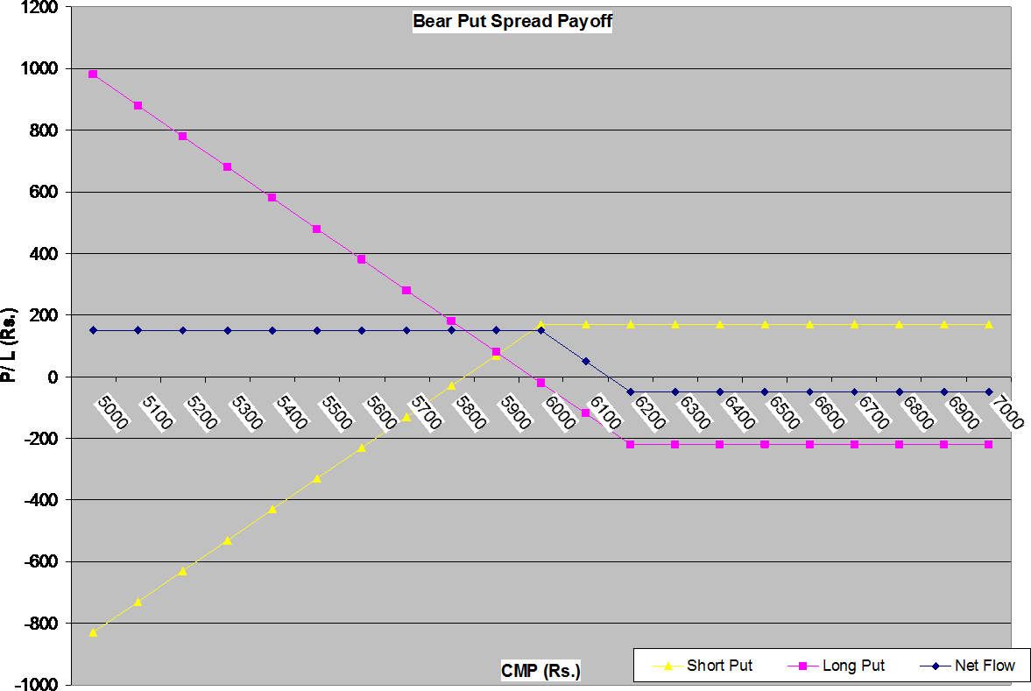

As can be seen from the picture above, it is a limited profit and limited loss position. Maximum profit in this position is 150 and maximum loss is 50. BEP for this position is 6150.

Horizontal Spread
Horizontal spread involves same strike, same type but different expiry options. This is also known as time spread or calendar spread. Here, it is not possible to draw the pay off chart as the expiries underlying the spread are different. Underlying reasoning behind horizontal spreads is that these two options would have different time values and the trader believes that difference between the time values of these two options would shrink or widen. This is essentially a play on premium difference between two options prices squeezing or widening.
Diagonal spread
Diagonal spread involves combination of options having same underlying but different expiries as well as different strikes. Again, as the two legs in a spread are in different maturities, it is not possible to draw pay offs here as well. These are much more complicated in nature and in execution. These strategies are more suitable for the OTC market than for the exchange traded markets.

Straddle
This strategy involves two options of same strike prices and same maturity. A long straddle position is created by buying a call and a put option of same strike and same expiry whereas a short straddle is created by shorting a call and a put option of same strike and same expiry.
Let us say a stock is trading at Rs 6,000 and premiums for ATM call and put options are 257 and 136 respectively.
Long Straddle
If a person buys both a call and a put at these prices, then his maximum loss will be equal to the sum of these two premiums paid, which is equal to 393. And, price movement from here in either direction would first result in that person recovering his premium and then making profit. This position is undertaken when trader’s view on price of the underlying is uncertain but he thinks that in whatever direction the market moves, it would move significantly in that direction.
Now, let us analyze his position on various market moves. Let us say the stock price falls to 5300 at expiry. Then, his pay offs from position would be:
Long Call: - 257 (market price is below strike price, so option expires worthless) Long Put: - 136 - 5300 + 6000 = 564
Net Flow: 564 – 257 = 307
As the stock price keeps moving down, loss on long call position is limited to premium paid, whereas profit on long put position keeps increasing.
Now, consider that the stock price shoots up to 6700. Long Call: -257 – 6000 + 6700 = 443
Long Put: -136
Net Flow: 443 – 136 = 307

As the stock price keeps moving up, loss on long put position is limited to premium paid, whereas profit on long call position keeps increasing.
Thus, it can be seen that for huge swings in either direction the strategy yields profits. However, there would be a band within which the position would result into losses. This position would have two Break even points (BEPs) and they would lie at “Strike – Total Premium” and “Strike + Total Premium”. Combined pay-off may be shown as follows:

Option | Call | Put
Long/Short | Long | Long
Strike | 6000 | 6000
Premium | 257 | 136
Spot | 6000
CMP | Long Call | Long Put | Net Flow
5000 | -257 | 864 | 607
5100 | -257 | 764 | 507
5200 | -257 | 664 | 407
5300 | -257 | 564 | 307
5400 | -257 | 464 | 207
5500 | -257 | 364 | 107
5600 | -257 | 264 | 7
5700 | -257 | 164 | -93
5800 | -257 | 64 | -193
5900 | -257 | -36 | -293
6000 | -257 | -136 | -393
6100 | -157 | -136 | -293
6200 | -57 | -136 | -193
6300 | 43 | -136 | -93
6400 | 143 | -136 | 7
6500 | 243 | -136 | 107
6600 | 343 | -136 | 207
6700 | 443 | -136 | 307
6800 | 543 | -136 | 407
6900 | 643 | -136 | 507
7000 | 743 | -136 | 607

1000
Straddle Payoff
5000 5100 5200 5300 5400 5500 5600 5700 5800 5900 6000 6100 6200 6300 6400 6500 6600 6700 6800 6900 7000
CMP (Rs.)
Long Call Long Put Net Flow

800

600

400

200
P/ L (Rs.)

0

-200

-400

-600

It may be noted from the table and picture, that maximum loss of Rs. 393 would occur to the trader if underlying expires at strike of option viz. 6000. Further, as long as underlying expires between 6393 and 5607, he would always incur the loss and that would depend on the level of underlying. His profit would start only after recovery of his total premium of Rs. 393 in either direction and that is the reason there are two breakeven points in this strategy.
Short Straddle
This would be the exact opposite of long straddle. Here, trader’s view is that the price of underlying would not move much or remain stable. So, he sells a call and a put so that he can profit from the premiums. As position of short straddle is just opposite of long straddle, the payoff chart would be just inverted, so what was loss for long straddle would become profit for short straddle. Position may be shown as follows:

Option | Call | Put
Long/Short | Short | Short
Strike | 6000 | 6000
Premium | 257 | 136
Spot | 6000
CMP | Short Call | Short Put | Net Flow
5000 | 257 | -864 | -607
5100 | 257 | -764 | -507
5200 | 257 | -664 | -407

5300 | 257 | -564 | -307
5400 | 257 | -464 | -207
5500 | 257 | -364 | -107
5600 | 257 | -264 | -7
5700 | 257 | -164 | 93
5800 | 257 | -64 | 193
5900 | 257 | 36 | 293
6000 | 257 | 136 | 393
6100 | 157 | 136 | 293
6200 | 57 | 136 | 193
6300 | -43 | 136 | 93
6400 | -143 | 136 | -7
6500 | -243 | 136 | -107
6600 | -343 | 136 | -207
6700 | -443 | 136 | -307
6800 | -543 | 136 | -407
6900 | -643 | 136 | -507
7000 | -743 | 136 | -607

600
Short Straddle Payoff
5000 5100 5200 5300 5400 5500 5600 5700 5800 5900 6000 6100 6200 6300 6400 6500 6600 6700 6800 6900 7000
CMP (Rs.)
Short Call Short Put Net Flow

400

200

0

-200
P/ L (Rs.)

-400

-600

-800

-1000

It should be clear that this strategy is limited profit and unlimited loss strategy and should be undertaken with significant care. Further, it would incur the loss for trader if market moves significantly in either direction – up or down.

Strangle
This strategy is similar to straddle in outlook but different in implementation, aggression and cost.
Long Strangle
As in case of straddle, the outlook here (for the long strangle position) is that the market will move substantially in either direction, but while in straddle, both options have same strike price, in case of a strangle, the strikes are different. Also, both the options (call and put) in this case are out-of-the-money and hence the premium paid is low.
Let us say the cash market price of a stock is 6100. 6200 strike call is available at 145 and 6000 put is trading at a premium of 140. Both these options are out-of-the-money.
If a trader goes long on both these options, then his maximum cost would be equal to the sum of the premiums of both these options. This would also be his maximum loss in worst case situation. However, if market starts moving in either direction, his loss would remain same for some time and then reduce. And, beyond a point (BEP) in either direction, he would make money. Let us see this with various price points.

If spot price falls to 5700 on maturity, his long put would make profits while his long call option would expire worthless.
Long Call: - 145
Long Put: -140 – 5700 + 6000 = 160
Net Position: 160 – 145 = 15
As price continues to go south, long put position will become more and more profitable and long call’s loss would be maximum limited to the premium paid.

In case stock price goes to 6800 at expiry, long call would become profitable and long put would expire worthless.
Long Call: -145 – 6200 + 6800 = 455
Long Put: -140
Net Position: 455 – 140 = 315
The pay off chart for long strangle is shown below:

Option | Call | Put
Long/Short | Long | Long
Strike | 6200 | 6000
Premium | 145 | 140
Spot | 6100
CMP | Long Call | Long Put | Net Flow
5100 | -145 | 760 | 615
5200 | -145 | 660 | 515
5300 | -145 | 560 | 415
5400 | -145 | 460 | 315

5500 | -145 | 360 | 215
5600 | -145 | 260 | 115
5700 | -145 | 160 | 15
5800 | -145 | 60 | -85
5900 | -145 | -40 | -185
6000 | -145 | -140 | -285
6100 | -145 | -140 | -285
6200 | -145 | -140 | -285
6300 | -45 | -140 | -185
6400 | 55 | -140 | -85
6500 | 155 | -140 | 15
6600 | 255 | -140 | 115
6700 | 355 | -140 | 215
6800 | 455 | -140 | 315
6900 | 555 | -140 | 415
7000 | 655 | -140 | 515
7100 | 755 | -140 | 615

1000
Long Strangle Payoff
5100 5200 5300 5400 5500 5600 5700 5800 5900 6000 6100 6200 6300 6400 6500 6600 6700 6800 6900 7000 7100
CMP (Rs.)
Long Call Long Put Net Flow

800

600

400
P/ L (Rs.)

200

0

-200

-400

In this position, maximum profit for the trader would be unlimited in both the directions – up or down and maximum loss would be limited to Rs. 285, which would occur if underlying expires at any price between 6000 and 6200. Position would have two BEPs at 5715 and 6485. Until underlying crosses either of these prices, trader would always incur loss.

Short Strangle
This is exactly opposite to the long strangle with two out-of-the-money options (call and put) shorted. Outlook, like short straddle, is that market will remain stable over the life of options. Pay offs for this position will be exactly opposite to that of a long strangle position. As always, the short position will make money, when the long position is in loss and vice versa.
Option | Call | Put
Long/Short | Short | Short
Strike | 6200 | 6000
Premium | 145 | 140
Spot | 6100
CMP | Short Call | Short Put | Net Flow
5100 | 145 | -760 | -615
5200 | 145 | -660 | -515
5300 | 145 | -560 | -415
5400 | 145 | -460 | -315
5500 | 145 | -360 | -215
5600 | 145 | -260 | -115
5700 | 145 | -160 | -15
5800 | 145 | -60 | 85
5900 | 145 | 40 | 185
6000 | 145 | 140 | 285
6100 | 145 | 140 | 285
6200 | 145 | 140 | 285
6300 | 45 | 140 | 185
6400 | -55 | 140 | 85
6500 | -155 | 140 | -15
6600 | -255 | 140 | -115
6700 | -355 | 140 | -215
6800 | -455 | 140 | -315
6900 | -555 | 140 | -415
7000 | -655 | 140 | -515
7100 | -755 | 140 | -615

400
Short Strangle Payoff
5100 5200 5300 5400 5500 5600 5700 5800 5900 6000 6100 6200 6300 6400 6500 6600 6700 6800 6900 7000 7100
CMP (Rs.)
Short Call Short Put Net Flow

200

0

-200
P/ L (Rs.)

-400

-600

-800

-1000

In this position, maximum loss for the trader would be unlimited in both the directions – up or down and maximum profit would be limited to Rs. 285, which would occur if underlying expires at any price between 6000 and 6200. Position would have two BEPs at 5715 and 6485. Until underlying crosses either of these prices, trader would always make profit.

Covered Call
This strategy is used to generate extra income from existing holdings in the cash market. If an investor has bought shares and intends to hold them for some time, then he would like to earn some income on that asset, without selling it, thereby reducing his cost of acquisition. So how does an investor continue to hold on to the stock, earn income and reduce acquisition cost? Lets us see:
Suppose an investor buys a stock in the cash market at Rs. 1590 and also sells a call option with a strike price of 1600, thereby earning Rs. 10 as premium. If the stock price moves up from 1590 level, he makes profit in the cash market but starts losing in the option trade. For example, if Stock goes to 1640,
Long Cash: Profit of 1640 – 1590 = 50
Short Call: – 1640 + 1600 + 10 = -30
Net Position: 50 – 30 = 20
If the stock moves below 1590 level, he loses in the cash market, but gets to keep the premium as income. For example, if Stock goes to 1520,

Long Cash: 1520 – 1590 = -70
Short Call: + 10 (Long call holder will not exercise his right as he can buy the stock from the market at a price lower than strike, so he will let the option expire and the seller gets to keep the premium)
Net Position: -70 + 10 = -60
Therefore, combined position of long stock and short call would generate the pay-off as defined in the table and picture below:

Long Stock | 1590
Strike Price | 1600
Premium | 10
CMP | Stock | Call | Net
1490 | -100 | 10 | -90
1500 | -90 | 10 | -80
1510 | -80 | 10 | -70
1520 | -70 | 10 | -60
1530 | -60 | 10 | -50
1540 | -50 | 10 | -40
1550 | -40 | 10 | -30
1560 | -30 | 10 | -20
1570 | -20 | 10 | -10
1580 | -10 | 10 | 0
1590 | 0 | 10 | 10
1600 | 10 | 10 | 20
1610 | 20 | 0 | 20
1620 | 30 | -10 | 20
1630 | 40 | -20 | 20
1640 | 50 | -30 | 20
1650 | 60 | -40 | 20
1660 | 70 | -50 | 20
1670 | 80 | -60 | 20
1680 | 90 | -70 | 20
1690 | 100 | -80 | 20

150
Covered Call Payoff
1490 1500 1510 1520 1530 1540 1550 1560 1570 1580 1590 1600 1610 1620 1630 1640 1650 1660 1670 1680 1690
CMP (Rs.)
Net Stock Call

100

50

0
P/ L (Rs.)

-50

-100

-150

From the table and the pay off chart we can see that the net position of a covered call strategy looks like ‘short put’ with a strike of 1600. This is called synthetic short put position.
If at that point of time, a 1600 strike put is available at any price other than Rs.20 (let us say Rs.17), an arbitrage opportunity exists, where the trader can create a synthetic short put position (covered call), earn a Rs. 20 premium and use the proceeds to buy a 1600 put for Rs.17, thereby making a risk free profit of Rs.3. Indeed, one needs to also provide for frictions in the market like brokerage, taxes, administrative costs, funding costs etc.
The most important factor in this strategy is the strike of the sold call option. If strike is close to the prevailing price of underlying stock, it would fetch higher premium upfront but would lock the potential gain from the stock early. And, if strike is too far from the current price of underlying, while it would fetch low upfront premium, would provide for longer ride of money on underlying stock. One has to decide on this subject based on one’s view on the stock and choice between upfront premium from the option and potential gain from underlying.
A simple perspective on strike choice for covered call is that, till the time the cash market price does not reach the pre determined exit price, the long cash position can be used to sell calls of that target strike price. As long as price stays below that target price (let’s say 1600 in our case), we can write call option of 1600 strike and keep earning the premium. The moment 1600 is reached in the spot market, we can sell in the cash market and also cover the short call position.

Protective Put
Any investor, long in the cash market, always runs the risk of a fall in prices and thereby reduction of portfolio value and MTM losses. A mutual fund manager, who is anticipating a fall, can either sell his entire portfolio or short futures to hedge his portfolio. In both cases, he is out of the market, as far as profits from upside are concerned. What can be done to remain in the market, reduce losses but gain from the upside? Buy insurance!
By buying put options, the fund manager is effectively taking a bearish view on the market and if his view turns right, he will make profits on long put, which will be useful to negate the MTM losses in the cash market portfolio.
Let us say an investor buys a stock in the cash market at 1600 and at the same time buys a put option with strike of 1600 by paying a premium of Rs. 20.
Now, if prices fall to 1530 from here:
Long Cash: Loss of 1600 – 1530 = - 70 Long Put: Profit of – 20 – 1530 + 1600 = 50
Net Position: -20
For all falls in the market, the long put will turn profitable and the long cash will turn loss making, thereby reducing the overall losses only to the extent of premium paid (if strikes are different, losses will be different from premium paid)
In case prices rise to 1660
Long Cash: Profit of 1660 – 1600 = 60 Long Put: Loss of 20
Net Position: 60 – 20 = 40
As price keeps rising, the profits will keep rising as losses in long put will be maximum to the extent of premium paid, but profits in long cash will keep increasing. Combined position would look like as follows:

Long Cash | 1600
Strike Price | 1600
Premium | 20
CMP | Long Cash | Long Put | Net
1500 | -100 | 80 | -20
1510 | -90 | 70 | -20
1520 | -80 | 60 | -20
1530 | -70 | 50 | -20
1540 | -60 | 40 | -20
1550 | -50 | 30 | -20
1560 | -40 | 20 | -20
1570 | -30 | 10 | -20
1580 | -20 | 0 | -20
1590 | -10 | -10 | -20

1600 | 0 | -20 | -20
1610 | 10 | -20 | -10
1620 | 20 | -20 | 0
1630 | 30 | -20 | 10
1640 | 40 | -20 | 20
1650 | 50 | -20 | 30
1660 | 60 | -20 | 40
1670 | 70 | -20 | 50
1680 | 80 | -20 | 60
1690 | 90 | -20 | 70
1700 | 100 | -20 | 80

150
Protective Put Payoff
1500 1510 1520 1530 1540 1550 1560 1570 1580 1590 1600 1610 1620 1630 1640 1650 1660 1670 1680 1690 1700
CMP (Rs.)
Net Long Cash Long Put

100

50

0
P/ L (Rs.)

-50

-100

-150
A protective put pay off is similar to that of long call. This is called synthetic long call position.

Collar
A collar strategy is an extension of covered call strategy. Readers may recall that in case of covered call, the downside risk remains for falling prices, i.e., if the stock price moves down, losses keep increasing (covered call is like short put). To put a floor to this downside, we long a put option, which essentially negates the downside of the short underlying/futures (or the synthetic short put).
In our example, we had assumed that a trader longs a stock @ 1590 and shorts a call option with a strike price of 1600 and receives Rs. 10 as premium. In this case, the BEP was 1580. If price fell below 1580, loss could be unlimited whereas if price rose above 1600, the profit was capped at Rs. 20.
To prevent the downside, let us say, we now buy an out-of-the-money put option of strike 1580 by paying a small premium of Rs. 7.

Now, if price of underlying falls to 1490 on maturity:
Long Stock: -1590 + 1490 = -100
Short Call: 10
Long Put: -7 – 1490 + 1580 = 83
Net Position: -100 + 10 + 83 = - 7 (in case of covered call this would have been -90)
If price rises to 1690 on maturity:
ong Stock: -1590 + 1690 = 100
Short Call: 10 – 1690 +1600 = - 80
Long Put: - 7
Net Position: 100 – 80 – 7 = 13 (in case of covered call this would have been + 20) Combined position (i.e. long underlying, short call and long put) is as follows:

Long Stock | 1590 |  | Long Put | 1580
Short Call | 1600 |  | Premium | 7
Call Premium | 10
CMP | Long Stock | Short Call | Long Put | Net
1490 | -100 | 10 | 83 | -7
1500 | -90 | 10 | 73 | -7
1510 | -80 | 10 | 63 | -7
1520 | -70 | 10 | 53 | -7
1530 | -60 | 10 | 43 | -7
1540 | -50 | 10 | 33 | -7
1550 | -40 | 10 | 23 | -7
1560 | -30 | 10 | 13 | -7
1570 | -20 | 10 | 3 | -7
1580 | -10 | 10 | -7 | -7
1590 | 0 | 10 | -7 | 3
1600 | 10 | 10 | -7 | 13
1610 | 20 | 0 | -7 | 13
1620 | 30 | -10 | -7 | 13
1630 | 40 | -20 | -7 | 13
1640 | 50 | -30 | -7 | 13
1650 | 60 | -40 | -7 | 13
1660 | 70 | -50 | -7 | 13
1670 | 80 | -60 | -7 | 13
1680 | 90 | -70 | -7 | 13
1690 | 100 | -80 | -7 | 13

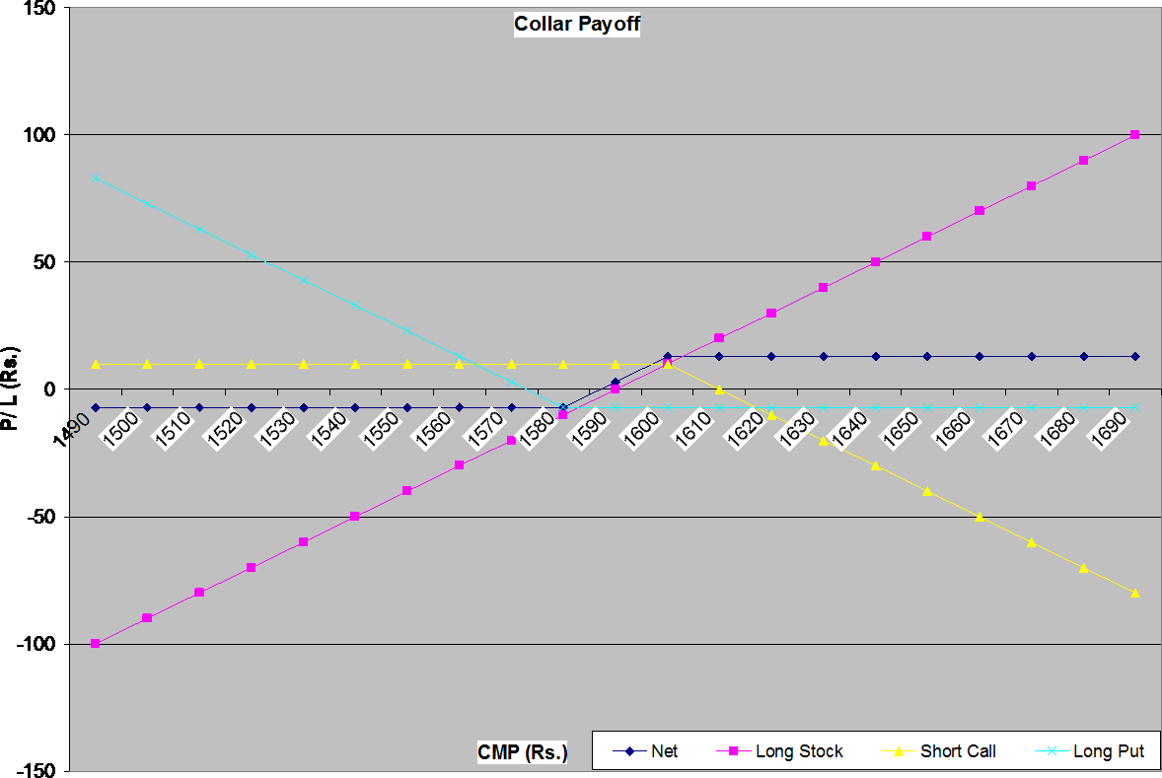

It is important to note here is that while the long put helps in reducing the downside risk, it also reduces the maximum profit, which a covered call would have generated. Also, the BEP has moved higher by the amount of premium paid for buying the out-of- the-money put option.

Butterfly Spread
As collar is an extension of covered call, butterfly spread is an extension of short straddle. We may recollect that downside in short straddle is unlimited if market moves significantly in either direction. To put a limit to this downside, along with short straddle, trader buys one out of the money call and one out of the money put. Resultantly, a position is created with pictorial pay-off, which looks like a butterfly and so this strategy is called “Butterfly Spread”.
Butterfly spread can be created with only calls, only puts or combinations of both calls and puts. Here, we are creating this position with help of only calls. To do so, trader has to take following positions in three different strikes and same maturity options:
Long Call 1 with strike of 6000 and premium paid Rs. 230 Short Call 2 with strike of 6100 and premium received Rs. 150 Long Call 3 with strike of 6200 and premium paid of Rs. 100 Short Call 2 with strike of 6100 and premium received Rs. 150
Let us see what happens if on expiry price is:
- Less than or equal to 6000
- Equal to 6100
- More than or equal to 6200

Case I: Price at 6000 Long Call 1: -230
Short Call 2: 150
Long Call 3: - 100
Short Call 2: 150
Net Position: -230 + 150 – 100 + 150 = -30
For any price lower than 6000, all calls will be out-of-the-money so nobody will exercise. Hence buyers will lose premium and sellers/ writers will get to keep the premium. In all these situations, trader’s loss would be flat Rs. 30.
Case II: Price at 6100
Long Call 1: - 230 – 6000 + 6100 = - 130
Short Call 2: 150
Long Call 3: - 100
Short Call 2: 150
Net Position: - 130 + 150 – 100 + 150 = 70
This is the maximum profit point for this position. Both the shorted calls earn the premium for the trader. This entire premium is kept by the trader for all prices less than or equal to 6100.
Case III: Price at 6200 or higher
Long Call 1: - 230 – 6000 + 6200 = - 30 (This will keep increasing as price rises) Short Call 2: 150 – 6200 + 6100 = 50 (This will start getting losses as price increases) Long Call 3: - 100
Short Call 2: 150 – 6200 + 6100 = 50 (This will start getting losses as price increases) Net Position: - 30 + 50 – 100 + 50 = - 30
From 6200 or higher, the long calls will start making money for the trader whereas the short calls will be in losses. And, total of all 4 would always be equal to – 30. Following table and picture explain this position:
Option | Call | Call | Call | Call
Long/Short | Long | Short | Long | Short
Strike | 6000 | 6100 | 6200 | 6100
Premium | 230 | 150 | 100 | 150
Spot | 6100
CMP | Long Call 1 | Short Call 2 | Long Call 3 | Short Call 2 | Net Flow
5100 | -230 | 150 | -100 | 150 | -30
5200 | -230 | 150 | -100 | 150 | -30
5300 | -230 | 150 | -100 | 150 | -30
5400 | -230 | 150 | -100 | 150 | -30
5500 | -230 | 150 | -100 | 150 | -30
5600 | -230 | 150 | -100 | 150 | -30
5700 | -230 | 150 | -100 | 150 | -30
5800 | -230 | 150 | -100 | 150 | -30

5900 | -230 | 150 | -100 | 150 | -30
6000 | -230 | 150 | -100 | 150 | -30
6100 | -130 | 150 | -100 | 150 | 70
6200 | -30 | 50 | -100 | 50 | -30
6300 | 70 | -50 | 0 | -50 | -30
6400 | 170 | -150 | 100 | -150 | -30
6500 | 270 | -250 | 200 | -250 | -30
6600 | 370 | -350 | 300 | -350 | -30
6700 | 470 | -450 | 400 | -450 | -30
6800 | 570 | -550 | 500 | -550 | -30
6900 | 670 | -650 | 600 | -650 | -30
7000 | 770 | -750 | 700 | -750 | -30
7100 | 870 | -850 | 800 | -850 | -30

1000
Butterfly Spread Payoff
5100 5200 5300 5400 5500 5600 5700 5800 5900 6000 6100 6200 6300 6400 6500 6600 6700 6800 6900 7000 7100
CMP (Rs.)
Long Call 1 Short Call 2 Long Call 3 Short Call 2 Net Flow

800

600

400

200

0
P/ L (Rs.)

-200

-400

-600

-800

-1000
Cost of creating butterfly spread: -230 + 150 – 100 + 150 = - 30
Lower BEP = 6000 + 30 = 6030
Higher BEP = 6200 – 30 = 6170
This position can also be created with the help of only puts or combination of calls and puts. To create this position from puts, one needs to buy one highest strike option, sell two middle strike options and then again buy one lowest strike option. And, to create this position from combination of calls and puts, one need to buy one call at lowest strike, sell one call at middle strike, buy one put at highest strike and sell one put at middle strike. This is limited profit and limited loss strategy.

